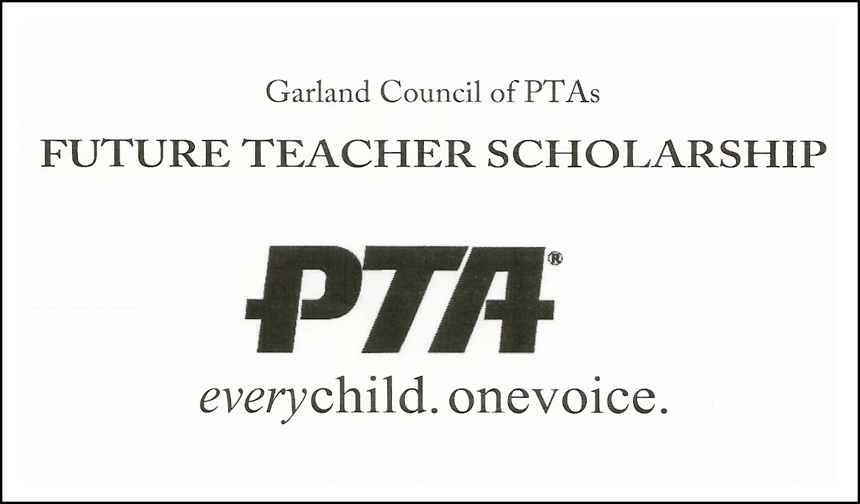

Guidelines for Application:

- All applicants will use the attached application to apply for the GISD Council of PTAs Future Teacher Scholarship.

- All applicants must be:
  - Planning to enter the teaching profession.
  - Attend an accredited college or university within the state of Texas.
  - Enroll in a minimum of nine (9) semester hours.

- All applications are due in the student’s high school Counseling office by 3:00pm, Friday, April 24th, 2020. No late applications will be accepted or considered. No exceptions.

- Due to the extraordinary circumstances this year, the PTA Scholarship Chairman will contact the high school counseling office to schedule interviews the week of April 27th. All student applicants will be notified by their high school Counselors regarding interview dates.

- Interviews will be conducted remotely by GISD Council of PTAs Board Members.

GISD Council of PTAs Contact Information:

Joe Luna, Scholarship Chairman
817-800-LUNA [5862]
Joeluna.gisdpta@gmail.com

